Practical 7

1. Display todays date?  
   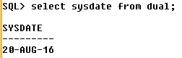
2. Display the date after 3 months from today?  
   
3. Display the date after four months where the current date is 12th Jan,2016?  
   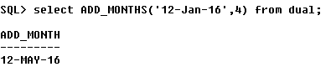
4. Display the date before 2 months from today?  
   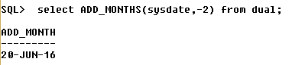
5. Display the date before 1.6 months from today?  
   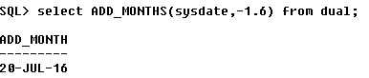
6. Display the last day of month?  
   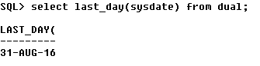
7. Display the last day of 12th Jan 2013?  
   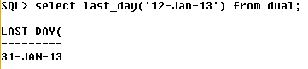
8. Display no of months between 31st Jan 2016 to 31st march 2016?  
   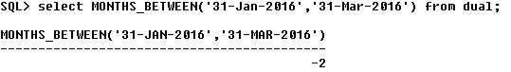
9. Display the no of months between 31st  March 2016 to 31th Jan 2016?  
   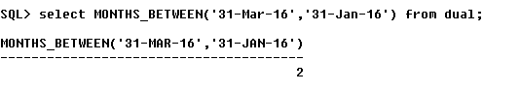
10. Display the no of months between 31st  March 2016 to 10th Jan 2016?  
    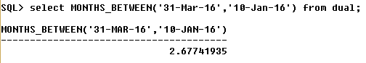
11. Display the date of next Monday of current month?  
    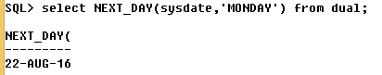
12. Display the date of immediate Friday of date 23rd Feb 2014?  
    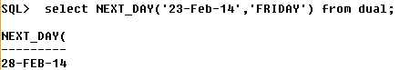
13. Find the length of your name?  
    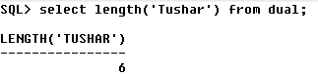
14. Display your name in capital letters?  
    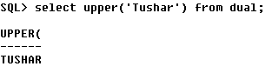
15. Display your name in lower letters?  
    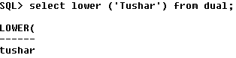
16. Using ltrim function remove the first two alphabets of your name?  
    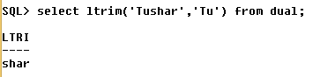
17. Using rtrim function remove the last three alphabets of your name?  
    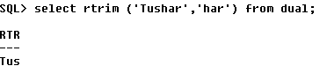
18. Using lpad and rpad?  
    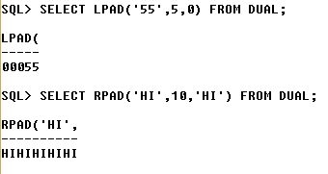
19. Display the name and salary from the table where all the names should be in capital?  
    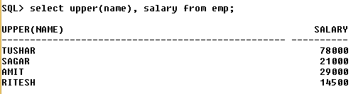
20. Display the length of the city and rename the output as city length from the table?  
    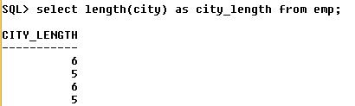
21. Using lpad function add two zeros to salary?  
    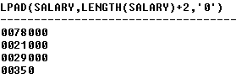
22. Using rpad function pad the city with 10 chars using \* symbol?  
    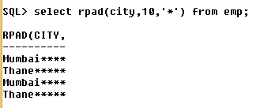
23. Display average salary of emp ?  
    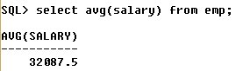
24. Count no of rows and display?  
    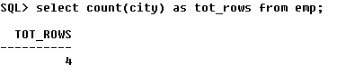
25. Display the no of distinct city from table?  
    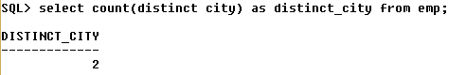
26. Display the min salary from table and output as minimum salary?  
    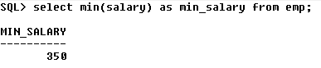
27. Display the max salary from table and output as maximum salary?  
    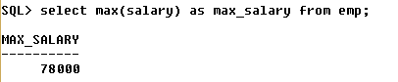
28. Find the total sum of salaries and rename output as total salary?  
    